23 December 2025
NAME: FADILA INUSA | Age: AD | Sex: F | Ref No:00010
Clinical Details: OBS |  |  | US:10
OBSTETRICS ULTRASOUND REPORT
Maternal Survey:
Internal Os is closed.
Adnexa appear unremarkable.
Foetal Survey: -
- Sonogram revealed SINGLE intrauterine foetus.
- Presentation : CEPHALIC, Lying LONGITUDINAL
- Placenta Location : POSTERIOR
- Amniotic fluid : ADEQUATE
- Cardiac activity : PRESENT AND REGULAR

Biometry:
- Gestation age based on BPD, AC and FL is approximately (GA): 38 weeks 02 day(s)
- Expected date of delivery by USG DD) : 06/01/2026 (±2 weeks)
- Foetal weight : 3.08 kg
- Gender : (NOT SEEN)
IMPRESSION: Single live intrauterine foetus at about 38 weeks 02 day(s).
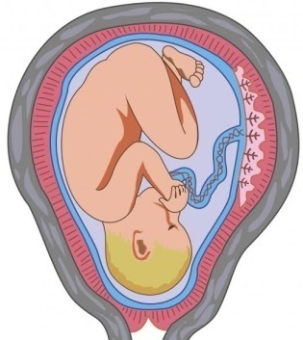
Ultrasound Specialist

